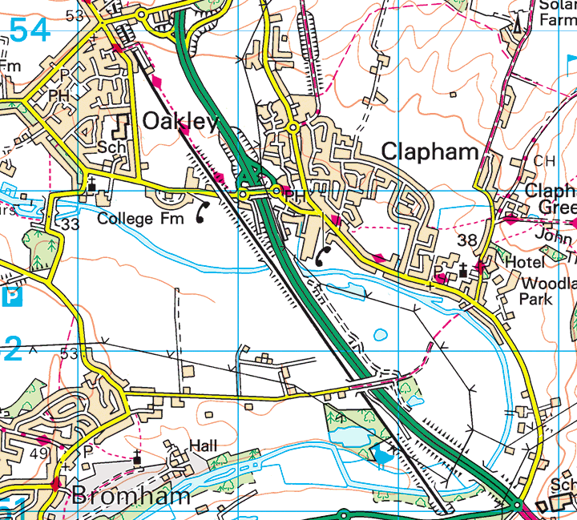
Oakley Road Overbridge

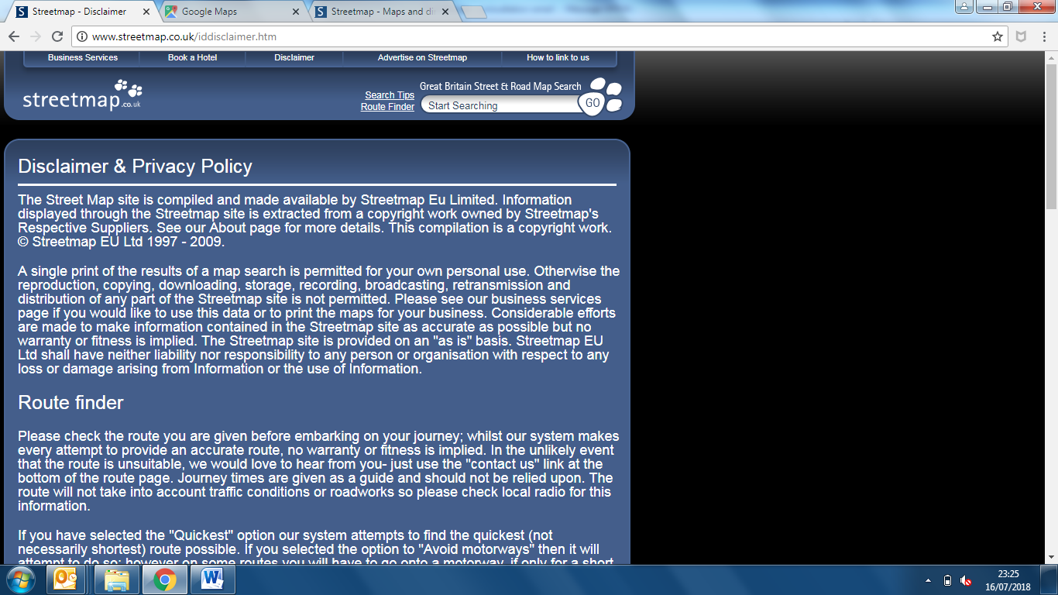
Oakley Road Overbridge
Location Plan

